

CS308 SOFTWARE ENGINEERING

THE DESIGN DOCUMENT

COFFEE TABLE

GROUP 2: Second Group

## ASSIST. PROF. DR.KANITA KARAĐUZOVIĆ-HADŽIABDIĆ

GROUP MEMBERS: Fuad Zulić, Ahmed Aletić, Vedat Ekşi, Ahmet Z.M. Altali, Imran Dautović

SARAJEVO, 2019

# DOCUMENT REVISION HISTORY

## First Revision

*Rev1.0 March 14 ,2019 – initial version*

Our first and initial version was completely different than the current one. That version included a project that was called „Weather Forecasting“ which would be a web page and work as an information box for getting and finding all informations that people need about certain day's weather. It would include day, month, year, temperature ( celsius or fahrenheit ), run, humidity, precipitation, and some other functionalities.

**Second Revision**

*Rev1.1 March 21 ,2019 – changed version*

In our last moments of making the final decision, we find out that it would be more better and useful to take our journey on another level and make it more challenging and harder for us as a group. We decided in our group that our next goal is to make „COFFEE TABLE“ as a panel for scheduling and creating much more better and bigger things with more functionalites which we will discuss and describe after, during our project making process. We have to highlight that our dear professor cooperate with us and helped us during our decision making. Thank You for that.

**Third Revision**

*Rev 1.2 April 15, 2019 – pre/final version*

During our regular meetings we finally decided that our project is going on right way and our final product need to be done. As we mentioned before during our „Project Documentation“ that we first were thinking of implementing weather forecasting, then after few consultations between us and our professor we decided to implement new project titled „Coffee Table“. It stayed like that until our final project meeting. Now our first object is to implement mentioned things and parts from our „Project Documentation“. We didn`t changed our project too much it stayed like it was before. We are now just working on making good and nice code which will run properly and working perfectly so that we can show our work.

**Fourth Revision**

*Rev 1.3 April 30 , 2019 – final version*

During our regular meetings we finally decided that our project is going on right way and our final product need to be done. As we mentioned before during our „Project Documentation“ that we first were thinking of implementing weather forecasting, then after few consultations between us and our professor we decided to implement new project titled „Coffee Table“. It stayed like that until our final project meeting.

To be honest we didnt implement all things and features that we imagined that we are going to do. Some things like map ( location ) we couldnt manage to make it work properly. We will mention this in another chapter. Also we have to say that this was our first time to use ASP.NET so basically all of us were doing it from the scratch. We are proud that we finish something so we could present it in front of you. Thank You for support during our work.

# OBJECTIVES

In this part we will try to make summary or overview of our project. What are main components and what we imagined to implement so that after we can show to all of other people. As its mentioned before our project title is „Coffee Table“. In our design document it will be all said how it should look like. First of all we did our revision and we wrote that we changed our project. First one was about „Weather Forecasting“ and now second one is about „Coffee Table“ and it stayed as our final decision. We stick to that project and now working on its implementation. Second thing that will be implemented are diagrams which will show flow of our program, all methods and functions thats gonna work and make project functional. We will implement UML and sequence diagrams so that every person can graphically see whats happening inside and how its working. It will be design such nice so that even person with low level of education can understand how it will work and what are main functions that will work. At the end we will implement our UI-User Interface which will show real work of our page with all implemented functions. It`s like prototype, initial version that will be shown graphicaly so it will leave just to code it and make it as its shown. Ofcourse our „Progres Report Table“ will be attached at the end so that our professor is familiar with all our work done by each member inside of our group. Thank You.

# CLASS DIAGRAM

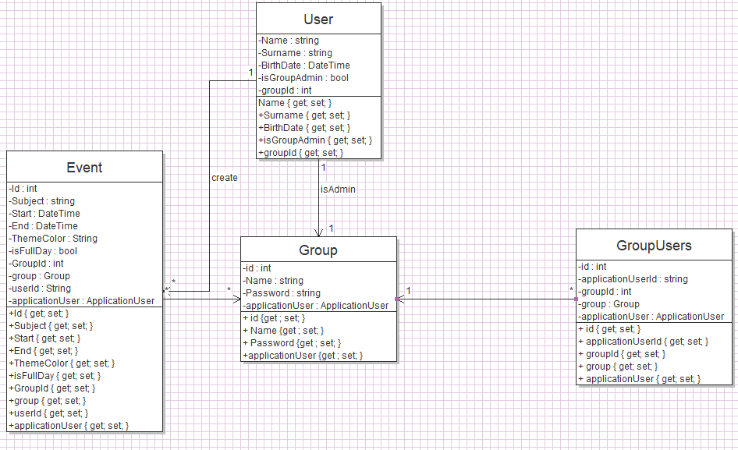

# DYNAMIC MODELS

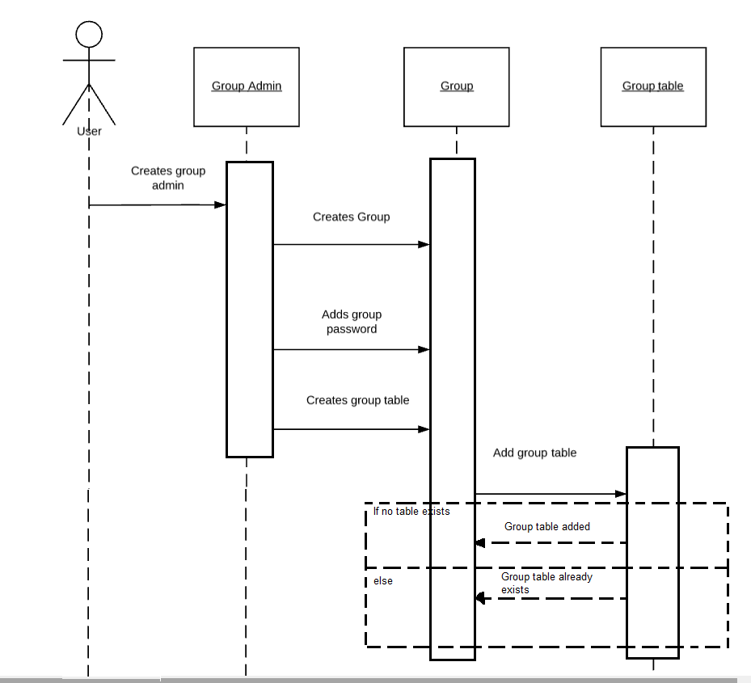

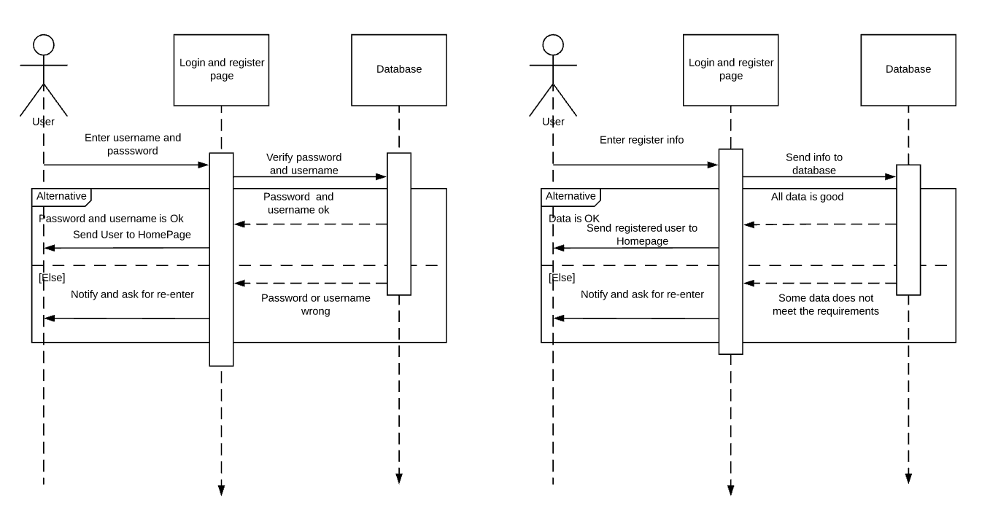

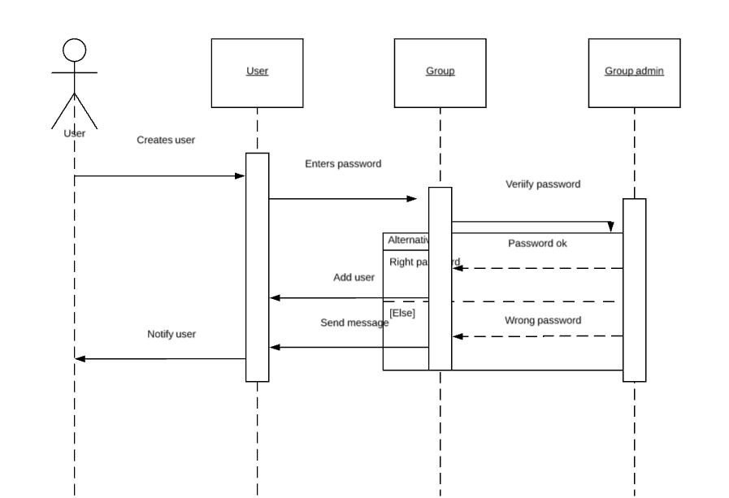

# USER INTERFACE

## WEB VERSION

**Home**

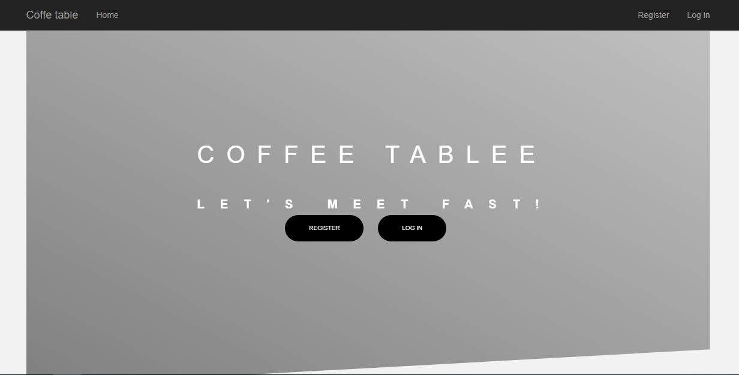

**Register**

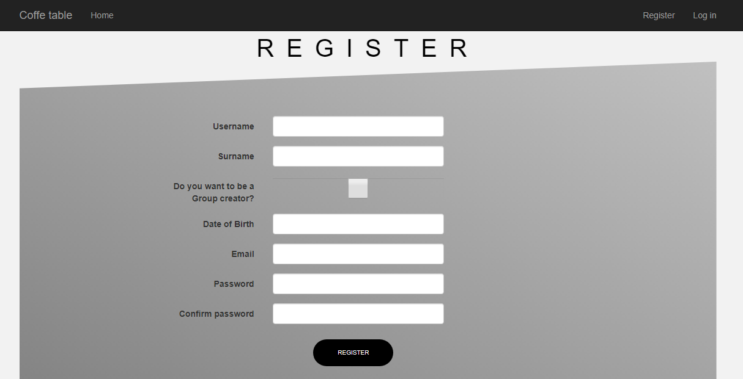

Login

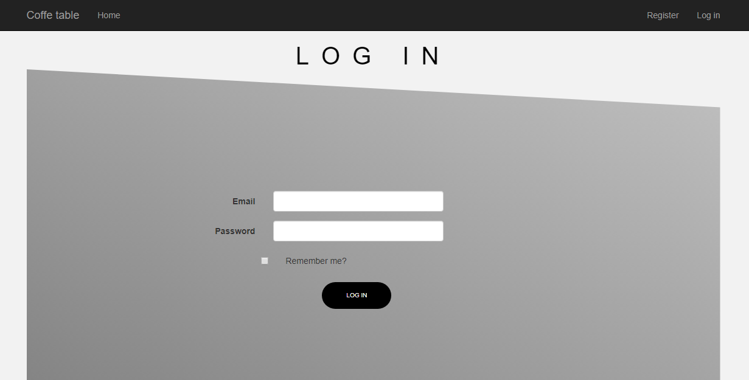

**Profile Page**

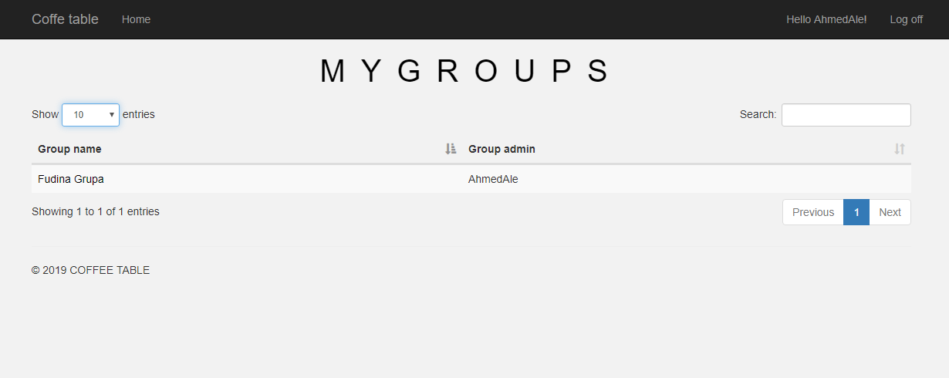

**Create a group**

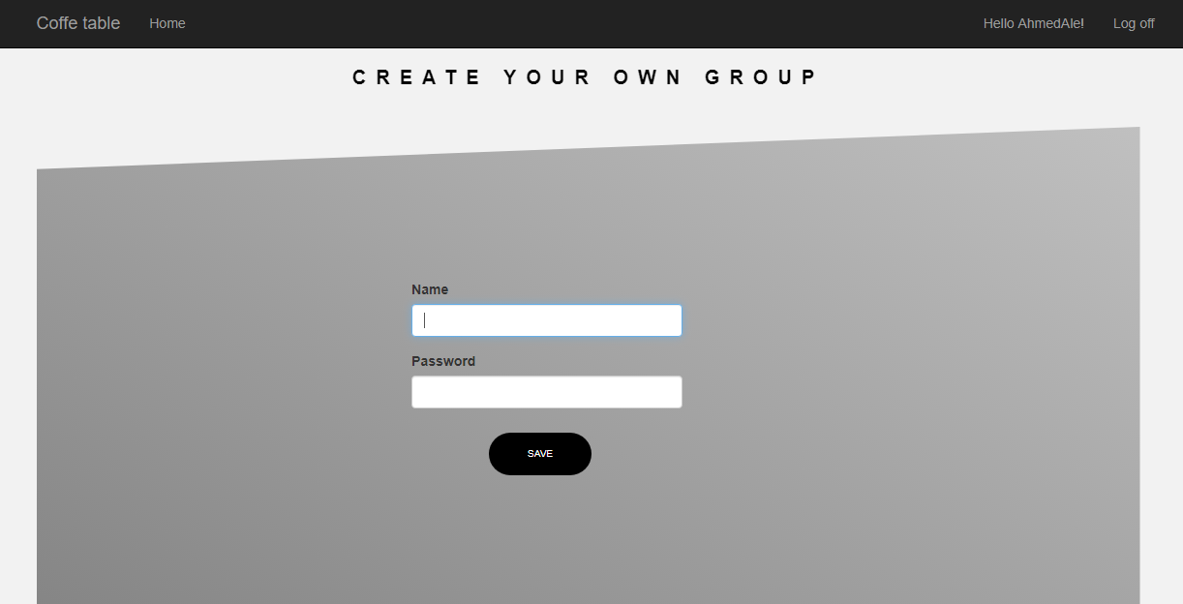

**List of groups**

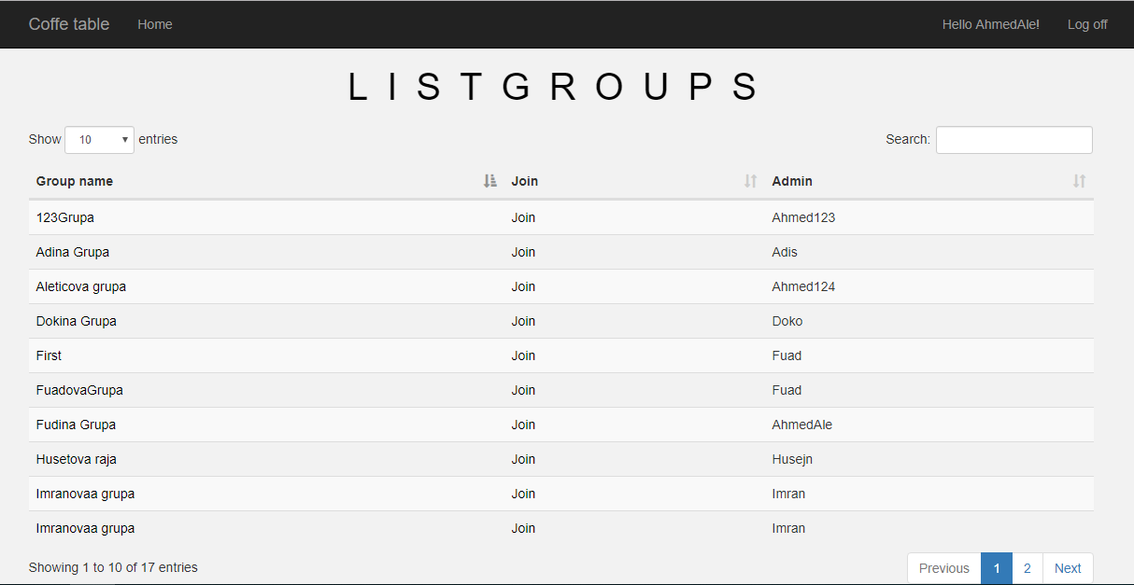

**In the group page**

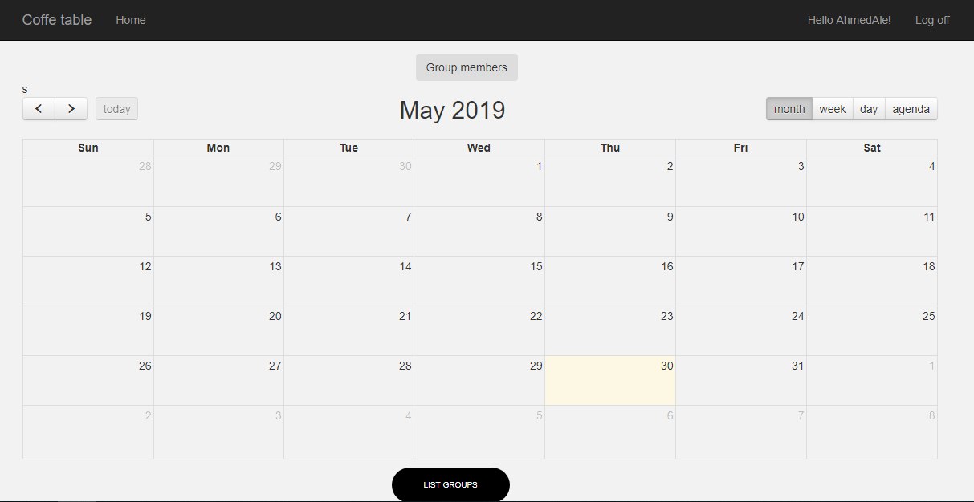

**Make an event**

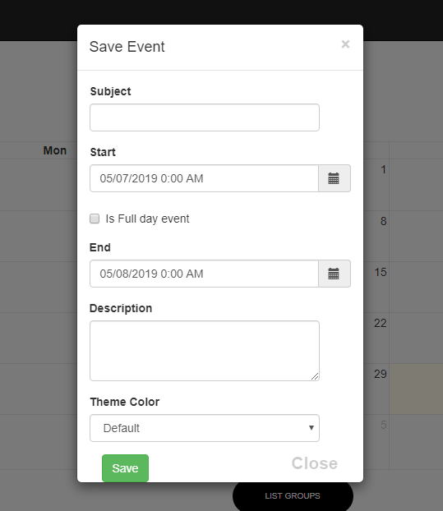

**COFFEE TABLE**

**Second Group**

**Meeting no: 1**

**Date: 16.4.2019**

**Members present: Members were present ( Fuad Zulić, Ahmed Aletić, Vedat Ekşi, Imran Dautović )**

**Members absent: Just Ahmet Z.M. Altali**

**Tasks:**

|  |  |  |  |  |
| --- | --- | --- | --- | --- |
| **Team member name** | **Task assigned** | **To be completed on** | **Last meeting tasks completed (Yes/No)** | **Signature** |
| Fuad Zulić | Make tables ( edit and delete buttons ), make calendar, events, and date time) | 25.4.2019 | Just part of it |  |
| Ahmed Aletić | Make Login button(authentication of login using SMS ) | 25.4.2019 | Just part of it |  |
| VedatEkşi | Make part of Database ( implement Models ) | 25.4.2019 | Just part of it |  |
| Ahmet Z.M. Altali | *ABSENT | 25.4.2019 | *ABSENT |  |
| Imran Dautović | Make Registration button ( email confirmation, all options about it ) | 25.4.2019 | Just part of it |  |

**COFFEE TABLE**

**Second Group**

**Meeting no: 2**

**Date: 25.4.2019**

**Members present: Members were present ( Fuad Zulić, Ahmed Aletić, Vedat Ekşi, Imran Dautović )**

**Members absent: Just Ahmet Z.M. Altali**

**Tasks:**

|  |  |  |  |  |
| --- | --- | --- | --- | --- |
| **Team member name** | **Task assigned** | **To be completed on** | **Last meeting tasks completed (Yes/No)** | **Signature** |
| Fuad Zulić | Make tables ( edit and delete buttons ), make calendar, events, and date time) | 7.5.2019 | Still not done |  |
| Ahmed Aletić | Make Login button(authentication of login using SMS ) | 7.5.2019 | Still not done |  |
| VedatEkşi | Make part of Database ( implement Models ) | 7.5.2019 | Still not done |  |
| Ahmet Z.M. Altali | *ABSENT | 7.5.2019 | *ABSENT |  |
| Imran Dautović | Make Registration button ( email confirmation, all options about it ) | 7.5.2019 | Still not done |  |

**COFFEE TABLE**

**Second Group**

**Meeting no: 3**

**Date: 7.5.2019**

**Members present: Members were present ( Fuad Zulić, Ahmed Aletić, Vedat Ekşi, Imran Dautović )**

**Members absent: Just Ahmet Z.M. Altali**

**Tasks:**

|  |  |  |  |  |
| --- | --- | --- | --- | --- |
| **Team member name** | **Task assigned** | **To be completed on** | **Last meeting tasks completed (Yes/No)** | **Signature** |
| FuadZulić | Make tables ( edit and delete buttons ), make calendar, events, and date time) | 28.5.2019 | No  ( Day of presenting whats done until it.) |  |
| Ahmed Aletić | Make Login button(authentication of login using SMS ) | 28.5.2019 | No  ( Day of presenting whats done until it.) |  |
| VedatEkşi | Make part of Database ( implement Models ) | 28.5.2019 | No  ( Day of presenting whats done until it.) |  |
| Ahmet Z.M. Altali | *ABSENT | 28.5.2019 | *ABSENT |  |
| Imran Dautović | Make Registration button ( email confirmation, all options about it ) | 28.5.2019 | No  ( Day of presenting whats done until it.) |  |

**COFFEE TABLE**

**Second Group**

**Meeting no: 4**

**Date: 28.5.2019 ( Presentation Day )**

**Members present: Members were present ( Fuad Zulić, Ahmed Aletić, Vedat Ekşi, Imran Dautović )**

**Members absent: Just Ahmet Z.M. Altali**

**Tasks:**

|  |  |  |  |  |
| --- | --- | --- | --- | --- |
| **Team member name** | **Task assigned** | **To be completed on** | **Last meeting tasks completed (Yes/No)** | **Signature** |
| FuadZulić | Make tables ( edit and delete buttons ), make calendar, events, and date time) | 28.5.2019 | Yes  ( Presentation  Day ) |  |
| Ahmed Aletić | Make Login button(authentication of login using SMS ) | 28.5.2019 | Yes ( Presentation  Day ) |  |
| VedatEkşi | Make part of Database ( implement Models ) | 28.5.2019 | Yes( Presentation  Day ) |  |
| Ahmet Z.M. Altali | *ABSENT | 28.5.2019 | *ABSENT |  |
| Imran Dautović | Make Registration button ( email confirmation, all options about it ) | 28.5.2019 | Yes( Presentation  Day ) |  |

***IMPORTANT NOTATION:*** We didnt implement whole project on GitHub until deadline. It was done, but we were trying to fix some things and make it a little bit more beautiful and functional. Our front-end was a little bit bad and we worked on it. Also we tried to impelent some features like „email confirmations“ when person finish registration or getting SMS when loggin in to your account and it took time from us. So to be honest and clear we didnt implement all of it on a time. After few days we did it. Sorry for it, and Thank You for understanding.